Resume

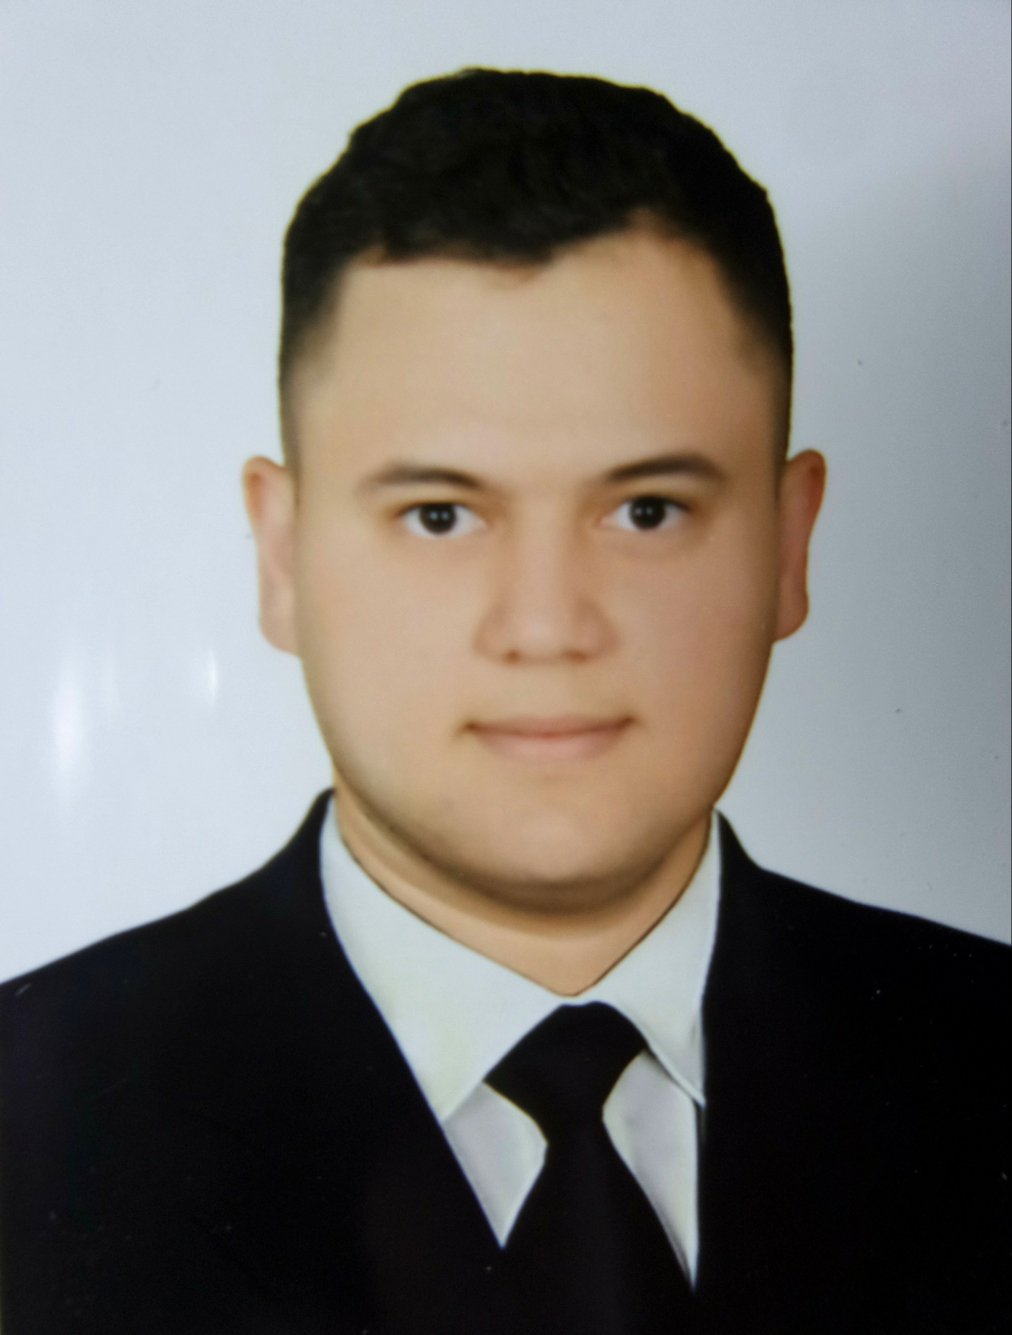

Personal Information

|  |  |  |  |
| --- | --- | --- | --- |
| Full Name | **Mohammad Raad Hussein** | Date of Birth | **1996/8/21** |
| Place of Birth | **Baghdad Al-Mansour** | Marital Status | **Single** |
| English Skills | **Good** | Computer Skills | **Very Good** |
| Nationality | **Iraqi** | Religion | **muslim** |
| Drive License | YES |  |  |

Education

|  |  |  |  |  |
| --- | --- | --- | --- | --- |
| Institute/University | Degree | City/Country | Major | Graduation Year |
| Technical Engineering College Baghdad | **B.A** | Iraq - Baghdad | Suryving Engineering | **2018** |

Work Experience / Responsibility / Duty

|  |
| --- |
| -Computer experience in Word Excel PowerPoint programs And also in Windows 7 and Windows 10 and in printing and in everything related to the computer and Auto Cad 2D 3D. |

Experience

|  |
| --- |
| -Computer course in Windows 7 and Windows 10 in the program Word Excel and PowerPoint and a course in project management also I am a good management company |

ــــــــــــــــــــــــــــــــــــــــــــــــــــــــ

Telephone: 07713454861 E-Mail: Mohammadraadmx9660@yahoo.com